Bio A notes
Section 12-1
Griffith and Transformation
In 1928, British scientist Fredrick Griffith was trying to learn how certain types of bacteria caused pneumonia.
He isolated two different strains of pneumonia bacteria from mice and grew them in his lab.
Griffith made two observations:
(1) The disease-causing strain of bacteria grew into smooth colonies on culture plates.
(2) The harmless strain grew into colonies with rough edges.
Griffith set up four individual experiments.
Experiment 1: Mice were injected with the disease-causing strain of bacteria. The mice developed pneumonia and died.
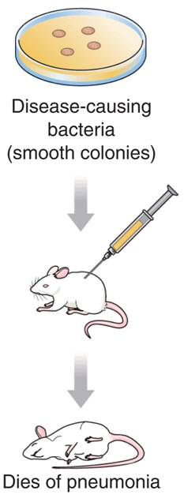
Experiment 2: Mice were injected with the harmless strain of bacteria. These mice didn’t get sick.
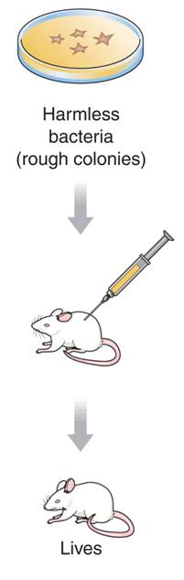
Experiment 3: Griffith heated the disease-causing bacteria. He then injected the heat-killed bacteria into the mice. The mice survived.
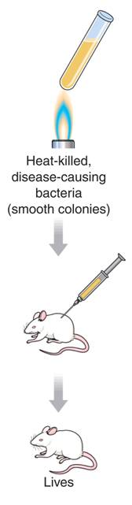
Experiment 4: Griffith mixed his heat-killed, disease-causing bacteria with live, harmless bacteria and injected the mixture into the mice. The mice developed pneumonia and died.
Griffith concluded that the heat-killed bacteria passed their disease-causing ability to the harmless strain.
Griffith called this process transformation because one strain of bacteria (the harmless strain) had changed permanently into another (the disease-causing strain).
Griffith hypothesized that a factor must contain information that could change harmless bacteria into disease-causing ones.
What is this transforming factor?
Scientists knew that viruses were made of DNA and protein, but they did not know what GENES (the hereditary material) was made of.
If Hershey and Chase could determine which part of the virus entered an infected cell, they would learn whether genes were made of protein or DNA.
They grew viruses in cultures containing radioactive isotopes of phosphorus-32 (³²P) and sulfur-35 (³⁵S).
Remember that DNA contains phosphorus and some amino acids contain sulfur.
If ³⁵S was found in the bacteria, it would mean that the viruses’ protein had been injected into the bacteria.
If ³²P was found in the bacteria, then it was the DNA that had been injected.
Nearly all the radioactivity in the bacteria was from phosphorus (³²P).
Hershey and Chase concluded that the genetic material of the bacteriophage was DNA, not protein.
The Components and Structure of DNA
DNA is made up of nucleotides. A nucleotide is a monomer of nucleic acids made up of a five-carbon sugar called deoxyribose, a phosphate group, and a nitrogenous base. There are four kinds of bases in in DNA:
    - adenine
    - guanine
    - cytosine
    - thymine
- The backbone of a DNA chain is formed by sugar and phosphate groups of each nucleotide.
- The nucleotides can be joined together in any order.
Chargaff's Rules
Erwin Chargaff discovered that:
The percentages of guanine [G] and cytosine [C] bases are almost equal in any sample of DNA.
The percentages of adenine [A] and thymine [T] bases are almost equal in any sample of DNA.

X-Ray Evidence
Rosalind Franklin used X-ray diffraction to get information about the structure of DNA. She aimed an X-ray beam at concentrated DNA samples and recorded the scattering pattern of the X-rays on film.
The Double Helix
Using clues from Franklin’s pattern, James Watson and Francis Crick built a model that explained how DNA carried information and could be copied.
Watson and Crick's model of DNA was a double helix, in which two strands were wound around each other.
Section 12-2
DNA and Chromosomes
In prokaryotic cells, DNA is located in the cytoplasm. Most prokaryotes have a single DNA molecule containing nearly all of the cell’s genetic information. Eukaryotic DNA is located in the cell nucleus inside chromosomes. The number of chromosomes varies widely from one species to the next.
DNA Replication
Each strand of the DNA double helix has all the information needed to reconstruct the other half by the mechanism of base pairing.
In most prokaryotes, DNA replication begins at a single point and continues in two directions.
In eukaryotic chromosomes, DNA replication occurs at hundreds of places. Replication proceeds in both directions until each chromosome is completely copied.
The sites where separation and replication occur are called replication forks.
Duplicating DNA
Before a cell divides, it duplicates its DNA in a process called replication.
Replication ensures that each resulting cell will have a complete set of DNA.
During DNA replication, the DNA molecule separates into two strands, then produces two new complementary strands following the rules of base pairing. Each strand of the double helix of DNA serves as a template for the new strand.
How Replication Occurs
DNA replication is carried out by enzymes that “unzip” a molecule of DNA.
Hydrogen bonds between base pairs are broken and the two strands of DNA unwind.
The principal enzyme involved in DNA replication is DNA polymerase.
DNA polymerase joins individual nucleotides to produce a DNA molecule and then “proofreads” each new DNA strand.
12-3 RNA and Protein Synthesis
Genes are coded DNA instructions that control the production of proteins.
RNA picks up the message from DNA and uses it to make proteins.

Similarities between DNA and RNA:
- Both consists of a long chain of nucleotides.
- Each nucleotide is made up of a 5-carbon sugar, a phosphate group, and a nitrogenous base.

Differences between RNA and DNA:
- The sugar in RNA is ribose instead of deoxyribose.
- RNA is generally single-stranded.
- RNA contains uracil in place of thymine.
Three main types of RNA and their functions:
- messenger RNA (mRNA) carries copies of instructions from DNA out of the nucleus to ribosomes for assembling amino acids into proteins.
- ribosomal RNA (rRNA) Ribosomes are made up of proteins and ribosomal RNA (rRNA).
- transfer RNA During protein construction, transfer RNA (tRNA) transfers each amino acid to the ribosome.

Transcription
RNA molecules are produced by copying part of a nucleotide sequence of DNA into a complementary sequence in RNA. This process is called transcription.
Transcription requires the enzyme RNA polymerase.
During transcription, RNA polymerase binds to DNA and separates the DNA strands.
RNA polymerase then uses one strand of DNA as a template from which nucleotides are assembled into a strand of RNA. RNA polymerase binds only to regions of DNA known as promoters. Promoters are signals in DNA that indicate to the enzyme where to bind to make RNA.
RNA Editing
The DNA of eukaryotic genes contains sequences of nucleotides, called introns, that are not involved in coding for proteins. The DNA sequences that code for proteins are called exons.
When RNA molecules are formed, introns and exons are copied from DNA. The introns are cut out of RNA molecules. The exons are then spliced together to form mRNA.

The Genetic Code
The genetic code is the “language” of mRNA instructions. The code is written using four “letters” (the bases: A, U, C, and G). A codon consists of three consecutive nucleotides on mRNA that specify a particular amino acid. Each codon specifies a particular amino acid that is to be placed on the polypeptide chain. Some amino acids can be specified by more than one codon.
There is one codon AUG that can either specify the amino acid methionine or serve as a “start” codon for protein synthesis. There are three “stop” codons that do not code for any amino acid. These “stop” codons signify the end of a polypeptide.
Use Fig 12-17 on p. 303 to determine which amino acids are coded by which bases in mRNA.
Try these:
AUG Methionine or start
AAA Lysine
CCC ________________________
GGG ________________________
UUU ________________________
AUA ________________________

Translation is the decoding of an mRNA message into a polypeptide chain (protein).
Translation takes place on ribosomes.
During translation, the cell uses information from messenger RNA to produce proteins. Messenger RNA is transcribed in the nucleus, and then enters the cytoplasm where it attaches to a ribosome.
Translation begins when an mRNA molecule attaches to a ribosome. As each codon of the mRNA molecule moves through the ribosome, the proper amino acid is brought into the ribosome by tRNA.
In the ribosome, the amino acid is transferred to the growing polypeptide chain. Each tRNA molecule carries only one kind of amino acid.
In addition to an amino acid, each tRNA molecule has three unpaired bases.
These bases, called the anticodon, are complementary to one mRNA codon. The ribosome binds new tRNA molecules and amino acids as it moves along the mRNA. The process continues until the ribosome reaches a stop codon.
Many proteins are enzymes, which catalyze and regulate chemical reactions.
Proteins are each specifically designed to build or operate a component of a living cell.

12–4 Mutations are changes in the genetic material.
Mutations that produce changes in a single gene are known as gene mutations.
Mutations that produce changes in whole chromosomes are known as chromosomal mutations.
Gene mutations
involving a change in one or a few nucleotides are known as point mutations because they occur at a single point in the DNA sequence. Point mutations include
- substitution. Substitutions usually affect no more than a single amino acid.
- Insertions.
- deletions.
The effects of insertions or deletions are more dramatic.
- The addition or deletion of a nucleotide causes a shift in the grouping of codons.
- Changes like these are called frameshift mutations. Frameshift mutations may change every amino acid that follows the point of the mutation and can alter a protein so much that it is unable to perform its normal functions.
Chromosomal Mutations
- Chromosomal mutations involve changes in the number or structure of chromosomes.
- Chromosomal mutations include deletions, duplications, inversions, and translocations

Significance of Mutations
Many mutations have little or no effect on gene expression. Some mutations are the cause of genetic disorders. Beneficial mutations may produce proteins with new or altered activities that can be useful.
Polyploidy is the condition in which an organism has extra sets of chromosomes.

12- 5 Gene Regulation: An Example
E. coli provides an example of how gene expression can be regulated.
An operon is a group of genes that operate together.
In E. coli, these genes must be turned on so the bacterium can use lactose as food.
Therefore, they are called the lac operon.
The lac genes are turned off by repressors and turned on by the presence of lactose.
On one side of the operon's three genes are two regulatory regions.
    - In the promoter (P) region, RNA polymerase binds and then begins transcription.
    - The other region is the operator (O).
  - When the lac repressor binds to the O region, transcription is not possible.
  - When lactose is added, sugar binds to the repressor proteins.
  - The repressor protein changes shape and falls off the operator and transcription is made possible
- Many genes are regulated by repressor proteins. Some genes use proteins that speed transcription. Sometimes regulation occurs at the level of protein synthesis.

Eukaryotic Gene Regulation
Operons are generally not found in eukaryotes. Most eukaryotic genes are controlled individually and have regulatory sequences that are much more complex than those of the lac operon. Many Eukaryotic promoters are usually found just before the TATA box, and consist of short DNA sequences. Eukaryotic genes have a sequence called the TATA box which seems to help position RNA polymerase.

Genes are regulated in a variety of ways by enhancer sequences.
Many proteins can bind to different enhancer sequences.
Some DNA-binding proteins enhance transcription by:
    - opening up tightly packed chromatin
    - helping to attract RNA polymerase
    - blocking access to genes

Development and Differentiation
As cells grow and divide, they undergo differentiation, meaning they become specialized in structure and function.
Hox genes control the differentiation of cells and tissues in the embryo. Careful control of expression in hox genes is essential for normal development. All hox genes are descended from the genes of common ancestors.

