Chapter 13 notes
13.1
I. Selective Breeding – choosing mates with desired characteristics to produce the next generation.
Nearly all domestic animals (cattle, sheep, goats, horses, dogs,) and most crop plants have been produced by selective breeding.
A. Hybridization is the crossing of dissimilar individuals to bring together the best of both organisms. Hybrids, are often hardier than either of the parents (hybrid vigor). Disease resistance X food production .
B. Inbreeding is the continued breeding of individuals with similar characteristics.
Serious genetic problems can result. Bulldogs.

II. Increasing Variation
induce mutations with radiation and chemicals.
This can produce a few mutants with desirable characteristics.
Example: scientists have developed hundreds of useful bacteria - clean up oil spills

13.2 Manipulating DNA
Scientists use different techniques to:
    - extract DNA from cells
    - cut DNA into smaller pieces
    - identify the sequence of bases in a DNA molecule
    - make unlimited copies of DNA
I. DNA extraction
  - Remove DNA by a simple chemical procedure.

II. Cutting DNA see p. 356
Biologists cut DNA into small fragments using restriction enzymes. Each restriction enzyme cuts DNA at a specific sequence of nucleotides.

CTTAAG
GAATTC

Add dotted lines where the restriction enzyme would cut this restriction site.

III. Separating DNA by gel electrophoresis
- DNA fragments are placed at one end of a porous gel, and an electric voltage is applied to the gel. When the power is turned on, the negatively charged DNA molecules move toward the positive end of the gel.

- restriction enzymes cut DNA into fragments, which are poured into wells
- electric voltage is applied to the gel which moves the DNA fragments. The smaller the DNA fragment, the faster and farther it will move across the gel.
- Bands can then be compared with other samples of DNA.
IV. Why do this?
Knowing the sequence of an organism’s DNA allows researchers to
1. study specific genes, to compare them with the genes of other organisms,
2. to discover the functions of different genes and gene combinations.

V. Making Copies
Polymerase chain reaction (PCR) is a technique that allows biologists to make copies of genes.
13.3 Cell transformation
I. Transformation – process by which a cell takes in foreign DNA. This external DNA becomes incorporated into the recipient’s DNA.
a. External DNA is first joined to a small plasmid (small circular DNA strand found in prokaryotes) which has a genetic marker—a gene that makes it possible to distinguish bacteria that carry the plasmid (and the foreign DNA) from those that don't.
II. Transforming Animal Cells
Many egg cells are large enough that DNA can be directly injected into the nucleus.
Enzymes may help to insert the foreign DNA into the chromosomes of the injected cell.

13.4 Transgenic Organisms contain genes from other species.
A. Microorganisms - Bacteria produce important substances useful for health and industry:
      - insulin
      - Human growth hormone
      - clotting factor
B. Animals
1. are used to study genes and to improve the food supply.
2. Mice with human genes make their immune systems act similarly to those of humans. This allows scientists to study the effects of diseases on the human immune system.
3. Researchers are trying to produce transgenic chickens that will be resistant to the bacterial infections that can cause food poisoning.

C. Plants
Transgenic plants are now an important part of our food supply.
Many of these plants contain a gene that produces a natural insecticide, so plants don’t have to be sprayed with pesticides.

D. Cloning

A clone is a member of a population of genetically identical cells produced from a single cell.
In 1997, Ian Wilmut cloned a sheep called Dolly.

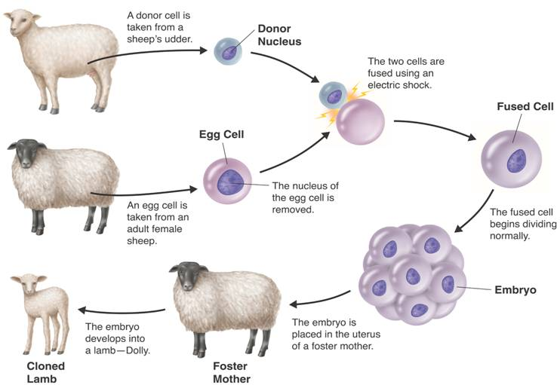

Researchers hope cloning will enable them to make copies of transgenic animals and help save endangered species.
Studies suggest that cloned animals may suffer from a number of genetic defects and health problems.

