Notes
Bio A Notes On Chapter 8 Photosynthesis
8-1
Why Study Photosynthesis?
- Photosynthesis removes carbon dioxide from the atmosphere.
2. Photosynthesis produces food
3. Photosynthesis produces oxygen.

Where do plants get the energy they need to produce food? Ans. From light, usually sunlight.
Organisms, such as plants, which make their own food, are called autotrophs.
Organisms, such as animals, that must obtain energy from the foods they consume are heterotrophs.

An important chemical compound that cells use to store and release energy is adenosine triphosphate, abbreviated ATP. ATP is used by all types of cells as their basic energy source.
ATP consists of:
      - adenine
      - ribose (a 5-carbon sugar)
      - 3 phosphate groups
Storing Energy
- ADP has two phosphate groups instead of three.
- A cell can store small amounts of energy by adding a phosphate group to ADP.
- Releasing Energy
- Energy stored in ATP is released by breaking the chemical bond between the second and third phosphates.

The energy from ATP is needed for many cellular activities, including
      - active transport across cell membranes
      - protein synthesis
      - muscle contraction.
Using Biochemical Energy
Most cells have only a small amount of ATP, because it is not a good way to store large amounts of energy.
Cells can regenerate ATP from ADP as needed by using the energy in foods like glucose.

8-2
Photosynthesis is the process in which green plants use the energy of sunlight to convert water and carbon dioxide into high-energy carbohydrates and oxygen.

Research into photosynthesis began centuries ago.
Van Helmont’s Experiment
In the 1600s, Jan van Helmont wanted to find out if plants grew by taking material out of the soil.
He determined the mass of a pot of dry soil and a small seedling, planted the seedling in the pot, and watered it regularly. After five years, the seedling was a small tree and had gained 75 kg, but the soil’s mass was almost unchanged.
Van Helmont concluded that the gain in mass came from water because water was the only thing he had added. Although he did not realize it, carbon dioxide in the air made a major contribution to the mass of his tree.
In photosynthesis, the carbon in carbon dioxide is used to make sugars and other carbohydrates.
Van Helmont had only part of the story, but he had made a major contribution to science in determining that the mass of a plant does NOT come from the soil.

Priestley’s Experiment
More than 100 years after van Helmont’s experiment, Joseph Priestley provided another insight into the process of photosynthesis.
Priestley took a candle, placed a glass jar over it, and watched as the flame gradually died out.
He reasoned that the flame needed something in the air to keep burning and when it was used up, the flame went out. That substance was oxygen.
Priestley then placed a live sprig of mint under the jar and allowed a few days to pass.
He found that the candle could be relighted and would remain lighted for a while.
The mint plant had produced the substance required for burning. In other words, it had released oxygen.
The experiments performed by van Helmont, Priestley, and others led to work by other scientists who finally discovered that, in the presence of light, plants transform carbon dioxide and water into carbohydrates, and they also release oxygen.
The Photosynthesis Equation
The equation for photosynthesis is:
6CO₂ + 6H₂O C₆H₁₂O₆ + 6O₂
carbon dioxide + water sugars + oxygen

What is the role of light and chlorophyll in photosynthesis?
Plants gather the sun's energy with light-absorbing molecules called pigments. The main pigment in plants is chlorophyll. There are two main types of chlorophyll:
      - chlorophyll a
      - chlorophyll b

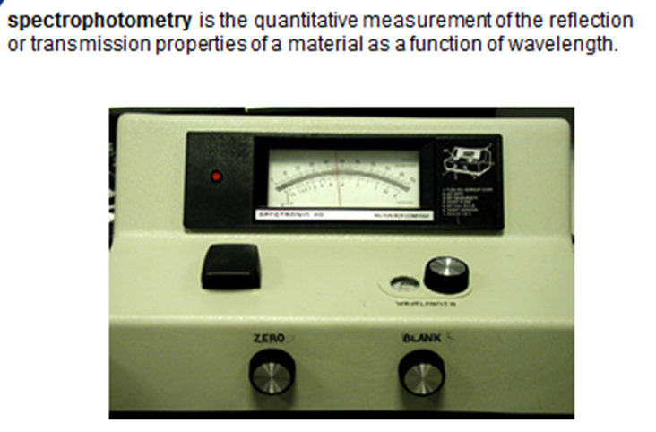

.
Using a spectrophotometer, scientists determined that chlorophyll absorbs light well in the blue-violet and red regions of the visible spectrum. Chlorophyll does not absorb light well in the green region of the spectrum. Green light is reflected by leaves, which is why plants look green.

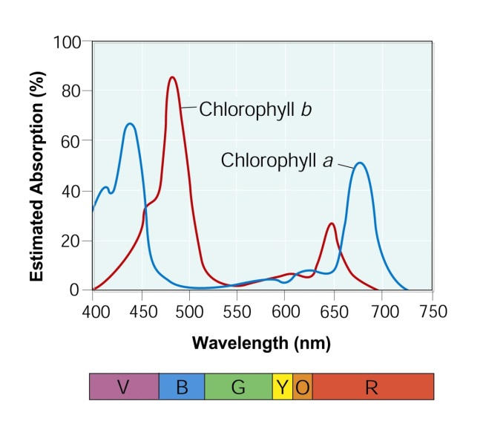

Light is a form of energy, so any compound that absorbs light also absorbs energy from that light.
When chlorophyll absorbs light, much of the energy is transferred directly to electrons in the chlorophyll molecule, raising the energy levels of these electrons.
These high-energy electrons are what make photosynthesis work.

8-3
In plants, photosynthesis takes place inside chloroplasts. Chloroplasts contain thylakoids—saclike photosynthetic membranes. Thylakoids are arranged in stacks known as grana. A singular stack is called a granum.
The reactions of photosystems include: the light-dependent reactions and the light-independent reactions, or Calvin cycle.
The light-dependent reactions take place within the thylakoid membranes.
The Calvin cycle takes place in the stroma, which is the region outside the thylakoid membranes.
Electron Carriers
When electrons in chlorophyll absorb sunlight, the electrons gain a great deal of energy.
Cells use electron carriers to transport these high-energy electrons from chlorophyll to other molecules.
One carrier molecule is NADP⁺.
Electron carriers, such as NADP⁺, transport electrons.
NADP⁺ accepts and holds 2 high-energy electrons along with a hydrogen ion (H⁺). This converts the NADP⁺ into NADPH.
The conversion of NADP⁺ into NADPH is one way some of the energy of sunlight can be trapped in chemical form.
The NADPH carries high-energy electrons to chemical reactions elsewhere in the cell.
These high-energy electrons are used to help build a variety of molecules the cell needs, including carbohydrates like glucose.

Light-Dependent Reactions
The light-dependent reactions require light.
The light-dependent reactions produce oxygen gas and convert ADP and NADP⁺ into the energy carriers ATP and NADPH.
Photosynthesis begins when pigments in photosystem II absorb light, increasing their energy level.
These high-energy electrons are passed on to the electron transport chain.
Enzymes on the thylakoid membrane break water molecules into:
      - hydrogen ions
      - oxygen atoms
      - energized electrons
- The energized electrons from water replace the high-energy electrons that chlorophyll lost to the electron transport chain.
- As plants remove electrons from water, oxygen is left behind and is released into the air.
- The hydrogen ions left behind when water is broken apart are released inside the thylakoid membrane.
- Energy from the electrons is used to transport H⁺ ions from the stroma into the inner thylakoid space.
- High-energy electrons move through the electron transport chain from photosystem II to photosystem I.
- Pigments in photosystem I use energy from light to re-energize the electrons.
- NADP⁺ then picks up these high-energy electrons, along with H⁺ ions, and becomes NADPH.
- As electrons are passed from chlorophyll to NADP⁺, more H⁺ ions are pumped across the membrane.
- Soon, the inside of the membrane fills up with positively charged hydrogen ions, which makes the outside of the membrane negatively charged.
- The difference in charges across the membrane provides the energy to make ATP.
- H⁺ ions cannot cross the membrane directly.
- The cell membrane contains a protein called ATP synthase that allows H⁺ ions to pass through it. As H⁺ ions pass through ATP synthase, the protein rotates. As it rotates, ATP synthase binds ADP and a phosphate group together to produce ATP. Because of this system, light-dependent electron transport produces not only high-energy electrons but ATP as well.

The light-dependent reactions use water, ADP, and NADP⁺ and produce oxygen, ATP, and NADPH.
These compounds provide the energy to build energy-containing sugars from low-energy compounds.

MORE TO COME ON THE CALVIN CYCLE

