Chapter 10 Cell Growth and Division

10–1 Cell Growth
Why do cells divide instead of growing indefinitely?

Limits to Cell Growth
The larger a cell becomes, the more demands the cell places on its DNA. In addition, the cell has more trouble moving enough nutrients and wastes across the cell membrane. The rate at which food, oxygen, water, and wastes are moved in and out of the cell is dependent on the surface area of the cell.
The rate at which food, oxygen, and water are used and waste is produced depends on the cell’s volume.

Ratio of Surface Area to Volume
As the length of a cell increases, its volume increases faster than the surface area.
The decrease in the cell’s ratio of surface area to volume makes it more difficult for the cell to move needed materials in and waste products out quickly enough for the cell to survive.
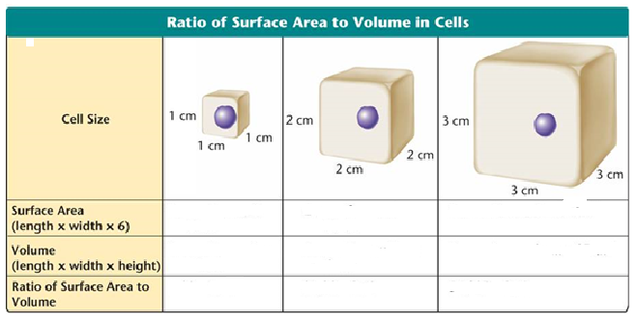

Division of the Cell
Before it becomes too large, a growing cell divides forming two “daughter” cells.
The process by which a cell divides into two new daughter cells is called cell division.

10-2 Cell Division

Asexual reproduction – new individuals or cells arise from a single parent – occurs by MITOSIS. Mitosis occurs for growth and repair of cells and tissues of multicellular organisms.
  - Plants – called vegetative propagation – budding in potatoes, bulbs, clippings, runners, onions.
  - Animals – budding in sponges, Hydra, regeneration in earthworms, sea stars
In eukaryotes, cell division occurs in two major stages.
The first stage, division of the cell nucleus, is called mitosis.
The second stage, division of the cell cytoplasm, is called cytokinesis.

Chromosomes
Genetic information is passed from one generation to the next on chromosomes. Before cell division, each chromosome is duplicated, or copied. Each chromosome consists of two identical “sister” chromatids.
Each pair of chromatids is attached at an area called the centromere. When the cell divides, the chromatids separate.
Each new cell gets one chromatid.

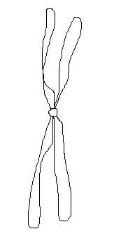
This is a duplicated chromosome. One half of a duplicated chromosome is called a chromatid. Label the centromere and the chromatids.

The Cell Cycle
The cell cycle is the series of events that cells go through as they grow and divide.
Interphase is the period of growth that occurs between cell divisions.
During the cell cycle: p. 245 Fig 10-4

    - a cell grows
    - prepares for division
    - divides to form two daughter cells, each of which begins the cycle again
The cell cycle consists of four phases:
      - G₁ (First Gap Phase)
      - S Phase
      - G₂ (Second Gap Phase)
      - M Phase

Label the Figure (see p. 245):

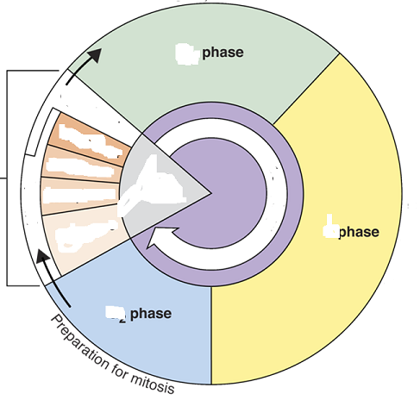

During G₁, the cell
      - increases in size
      - synthesizes new proteins and organelles
During the S phase,
chromosomes are replicated
      - DNA synthesis takes place. Once a cell enters the S phase, it usually completes the rest of the cell cycle.
During the G₂ Phase (Second Gap Phase)
    - organelles and molecules required for cell division are produced
    - Once G₂ is complete, the cell is ready to start the M phase—Mitosis

G0 – cells stop dividing. This happens to MOST cells . Cells in bone marrow – constantly divide to replace RBC – live only 120 days (no nucleus, so they cannot divide at all). Liver cells – stay in G0 unless part of the liver is removed by surgery.

Mitosis – type of cell division.
Purpose – growth and repair
Result - 2 offspring cells that are identical to each other and to the parent cell in # and kinds of chromosomes.

      - Prophase –
        - centrioles separate
        - spindle fibers form
        - nuclear membrane disappears
        - chromosomes become visible

      - Metaphase
        - chromosomes line up on equatorial plate
        - centrioles move to opposite ends
        - spindle fibers attach to centromeres

      - Anaphase
        - chromosomes separate
        - pinching of cell membrane begins (in animal cells); cell plate forms in plant cells

      - Telophase
        - chromosomes gather at opposite ends
        - nuclear membrane reforms

      - cytokinesis – final division of the cytoplasm.

In plants, a structure known as the cell plate forms midway between the divided nuclei. The cell plate gradually develops into a separating membrane.
A cell wall then begins to appear in the cell plate.

10-3 Regulating the Cell Cycle
Controls on Cell Division
Experiments show that normal cells will reproduce until they come into contact with other cells.
When cells come into contact with other cells, they respond by not growing.
This demonstrates that controls on cell growth and division can be turned on and off.
Cell Cycle Regulators
The cell cycle is regulated by a specific protein.
The amount of this protein in the cell rises and falls in time with the cell cycle.
Scientists called this protein cyclin because it seemed to regulate the cell cycle.
Cyclins regulate the timing of the cell
cycle in eukaryotic cells.
Uncontrolled Cell Growth
Cancer is a disorder in which some of the body's own cells lose the ability to control growth.
How are cancer cells different from other cells?
Cancer cells do not respond to the signals that regulate the growth of most cells. Cancer cells divide uncontrollably and form masses of cells called tumors that can damage the surrounding tissues.
Cancer cells may break loose from tumors and spread throughout the body, disrupting normal activities and causing serious medical problems or even death.

