Notes Respiration Chapter 9
Why study respiration?
Understanding respiration can help us prevent and treat obesity. 60-70% of Americans are overweight or obese.

What are mitochondrial diseases?
Mitochondria have their own DNA and defects in the DNA can cause a vast array of symptoms.
Dad’s sperm nucleus + Mom’s egg nucleus

After they fuse into ONE nucleus, scientists remove it from the mom’s egg cell and transfer it into a healthy donor egg cell in which the donor nucleus has been removed.

Remember most of an individual’s mitochondria come from the egg cell.
More reasons to study respiration:
Fitness, nutrition, and sports
Fitness, health, nutrition, and sports are big business. Understanding more about how the body uses energy contributes to each of these issues. Americans spend $1.5 billion on nutritional supplements each year.

9-1
Food serves as a source of raw materials for the cells in the body and as a source of energy.
Both plant and animal cells carry out the final stages of cellular respiration in the mitochondria.
One gram of the sugar glucose (C₆H₁₂O₆), when burned in the presence of oxygen, releases 3811 calories of heat energy.
A calorie is the amount of energy needed to raise the temperature of 1 gram of water 1 degree Celsius.
A Calorie (with a capital C)on a food label is actually a kilocalorie (1000 calories).

Cellular respiration is the process that releases energy by breaking down glucose and other food molecules in the presence of oxygen.
The equation for cellular respiration is:
6O₂ + C₆H₁₂O₆ → 6CO₂ + 6H₂O + Energy
oxygen + glucose → carbon dioxide + water + energy

Overview
If oxygen is present, glycolysis is followed by the Krebs cycle and the electron transport chain.
Glycolysis, the Krebs cycle, and the electron transport chain make up a process called cellular respiration. Fill in the blanks in the figure below:
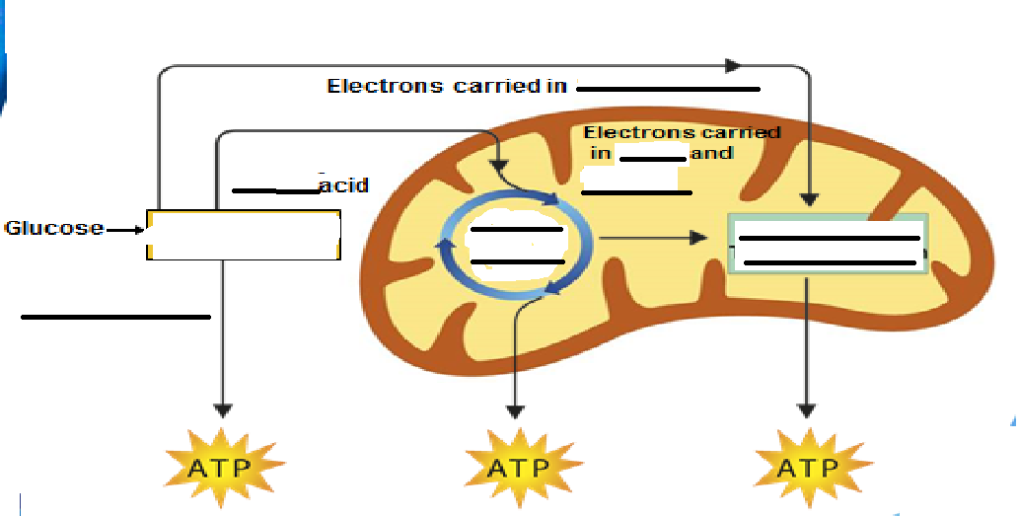
Each of the three stages of cellular respiration captures some of the chemical energy available in food molecules and uses it to produce ATP.
3 stages:
    - Glycolysis (lactic acid fermentation and alcoholic fermentation)
    - Kreb’s Cycle (Citric Acid Cycle)
    - Electron Transport Chain

Glycolysis is the process in which one molecule of glucose is broken in half, producing two molecules of pyruvic acid, a 3-carbon compound.
- At the beginning of glycolysis, the cell uses up 2 molecules of ATP to start the reaction.
- When glycolysis is complete, 4 ATP molecules have been produced.
- This gives the cell a net gain of 2 ATP molecules.
- One reaction of glycolysis removes 4 high-energy electrons, passing them to an electron carrier called NAD⁺.
- Each NAD⁺ accepts a pair of high-energy electrons and becomes an NADH molecule.
- The Advantages of Glycolysis
- The process of glycolysis is so fast that cells can produce thousands of ATP molecules in a few milliseconds.
- Glycolysis does not require oxygen.

Fermentation
- When oxygen is not present, glycolysis is followed by fermentation.
- Fermentation releases energy from food molecules by producing ATP in the absence of oxygen.
- The two main types of fermentation are lactic acid fermentation and alcoholic fermentation.

Alcoholic Fermentation
- Yeasts and a few other microorganisms use alcoholic fermentation, forming ethyl alcohol and carbon dioxide as wastes.
- The equation for alcoholic fermentation after glycolysis is:
- pyruvic acid + NADH → alcohol + CO₂ + NAD⁺

Lactic Acid Fermentation
- In many cells, pyruvic acid that accumulates as a result of glycolysis can be converted to lactic acid. Lactic acid fermentation converts glucose into lactic acid. This occurs in muscles if oxygen is not reaching cells fast enough.
- The first part of the equation is glycolysis.
- The second part shows the conversion of pyruvic acid to lactic acid.
- The equation for lactic acid fermentation after glycolysis is:
- pyruvic acid + NADH → lactic acid + NAD⁺
- The NADH molecule holds the electrons until they can be transferred to other molecules.
- By doing this, NAD⁺ helps to pass energy from glucose to other pathways in the cell.

9-2
The Krebs Cycle
In the presence of oxygen, pyruvic acid produced in glycolysis passes to the second stage of cellular respiration, the Krebs cycle. During the Krebs cycle, pyruvic acid is broken down into carbon dioxide in a series of energy-extracting reactions.
The Krebs cycle begins when pyruvic acid produced by glycolysis enters the mitochondrion.
One carbon molecule is removed, forming CO₂, and electrons are removed, changing NAD⁺ to NADH.
Coenzyme A joins the 2-carbon molecule, forming acetyl-CoA.
Acetyl-CoA then adds the 2-carbon acetyl group to a 4-carbon compound, forming citric acid.
Citric acid is broken down into a 5-carbon compound, then into a 4-carbon compound.
Two more molecules of CO₂ are released and electrons join NAD⁺ and FAD, forming NADH and FADH_{2.}
In addition, one molecule of ATP is generated.
The energy tally from 1 molecule of pyruvic acid is
      - 4 NADH
      - 1 FADH₂
      - 1 ATP
- In the presence of oxygen, those high-energy electrons can be used to generate huge amounts of ATP (during the Electron Transport Chain).

Electron Transport
- The electron transport chain uses the high-energy electrons from the Krebs cycle to convert ADP into ATP.
- High-energy electrons from NADH and FADH₂ are passed along the electron transport chain from one carrier protein to the next.
- At the end of the chain, an enzyme combines these electrons with hydrogen ions and oxygen to form water.
- As the final electron acceptor of the electron transport chain, oxygen gets rid of the low-energy electrons and hydrogen ions.
- When 2 high-energy electrons move down the electron transport chain, their energy is used to move hydrogen ions (H⁺) across the membrane. During electron transport, H⁺ ions build up in the intermembrane space, so it is positively charged.
- The other side of the membrane, from which those H⁺ ions are taken, is now negatively charged.
- The inner membranes of the mitochondria contain protein spheres called ATP synthases.
- As H⁺ ions escape through channels into these proteins, the ATP synthase spins.
- As it rotates, the enzyme grabs a low-energy ADP, attaching a phosphate, forming high-energy ATP.
- On average, each pair of high-energy electrons that moves down the electron transport chain provides enough energy to produce three molecules of ATP from ADP.
The Totals
- Glycolysis produces just 2 ATP molecules per molecule of glucose.
- The complete breakdown of glucose through cellular respiration, including glycolysis, results in the production of 36 molecules of ATP.
- Comparing Photosynthesis and Cellular Respiration
- The energy flows in photosynthesis and cellular respiration take place in opposite directions
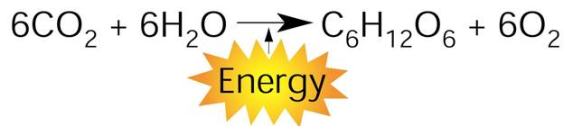
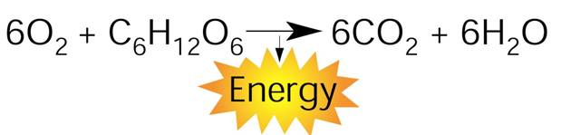
On a global level, photosynthesis and cellular respiration are also opposites.
- Photosynthesis removes carbon dioxide from the atmosphere and cellular respiration puts it back.
- Photosynthesis releases oxygen into the atmosphere and cellular respiration uses that oxygen to release energy from food.

